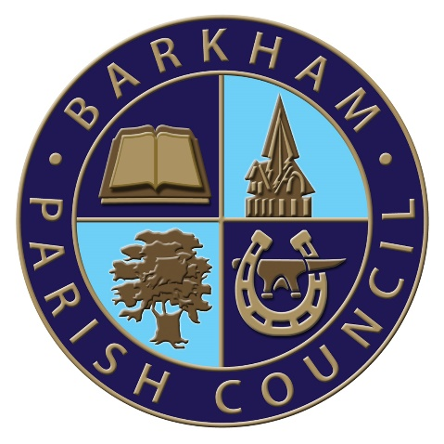
Barkham Parish Council
Arborfield Green Community Centre
Sheerlands Road
Arborfield
RG2 9ND
Tel: 0118 976 2089
Email: clerk@barkham-parishcouncil.org.uk
Clerk: Mrs Ellen Tims

Meeting of the Finance Committee Notice
To be held on Tuesday 24th November 2020
via the virtual platform Zoom,
Commencing at 9.30am

In accordance with the Local Authorities and Police and Crime Panels (Coronavirus) (Flexibility of Local Authority and Police and Crime Panel Meetings) (England and Wales) Regulations 2020 this meeting is to be held virtually.
If you would like to join the meeting, please contact the Clerk at clerk@barkham-parishcouncil.org.uk to receive a link to join the meeting.

The Business to be transacted is as shown under

- To appoint a new chairman of the committee
- To receive and consider public questions and comment.
- Apologies for absence with reason given
- Declaration of Members’ interests and requests for dispensation
- To approve the minutes from the last Finance Committee Meeting as being a true record of the meeting
- To receive the latest bank reconciliations and any unplanned expenditure from the RFO
- Reports on matters outstanding and actions arising from the minutes
- To discuss draft budget figures to be put to full council for consideration in December
- AOB
- To set the date of the next meeting
E. Tims
Clerk to the Council

The date of the next full Council meeting will be Tuesday 8th December 2020 via the virtual platform Zoom at a time to be agreed

The Parish Council does not meet in August

