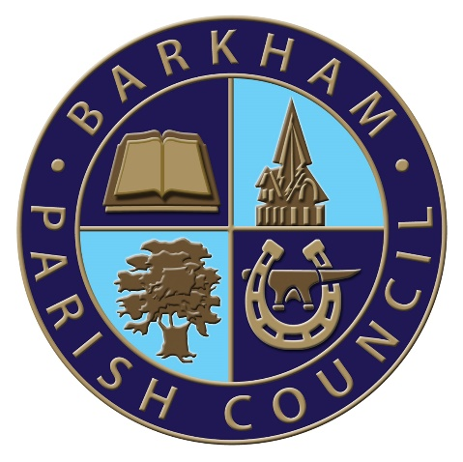
Barkham Parish Council
Arborfield Green Community Centre
Sheerlands Road
Arborfield
RG2 9ND
Tel: 0118 976 2089
Email: clerk@barkham-parishcouncil.org.uk
Clerk: Mrs Ellen Tims

First Meeting of the Road Safety Committee
To be held on Thursday 9th September 2021
At the Parish Office, Arborfield Green Community Centre
Commencing at 10am

The Business to be transacted is as shown under

1. To elect a chairperson for the Road Safety Committee

2. Apologies for absence with reasons given

3. Declaration of Members' interests and requests for dispensation

4. To discuss Vehicle Activation Signs (VAS) in general including the type required and ANPR

5. Restart of Speed Watch and Training sessions

6. Purchase of any further Speed Watch items required

7. AOB

E. Tims
Clerk to the Council

