BARKHAM PARISH COUNCIL

NOTICE OF VACANCY IN OFFICE OF PARISH COUNCILLOR

NOTICE IS HEREBY GIVEN pursuant to Section 87(2) of the Local Government Act 1972 that a vacancy has occurred on Barkham Parish Council following the resignation of Councillor Majid.

A by-election to fill the vacancy will be held if within 14 working days from the date below 10 electors from the parish give notice in writing to the Returning Officer, Electoral Services Office, Wokingham Borough Council, Civic Offices, Shute End, Wokingham of
a request for an election to fill the vacancy.

If no such notice is given the Parish Council will fill the post by co-option.

DATED this 27th day of September 2021

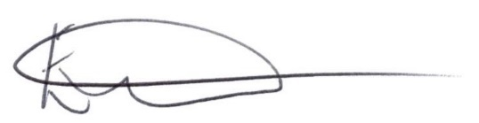
Clerk to the Parish Council

Printed and published by Returning Officer, Wokingham Borough Council, Civic Offices, Shute End, Wokingham. RG40 1WH

