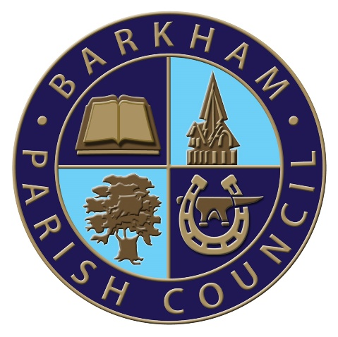
Barkham Parish Council
Arborfield Green Community Centre
Sheerlands Road
Arborfield
RG2 9ND
Tel: 0118 976 2089
Email: clerk@barkham-parishcouncil.org.uk
Clerk: Mrs Ellen Tims

Meeting of the Finance Committee Notice
To be held on Thursday 2nd December 2021
At the Parish Office, Arborfield Green Community Centre,
Commencing at 10am

PLEASE NOTE: YOU MUST NOT ATTEND THIS MEETING IF YOU HAVE ANY COVID SYMPTOMS OR HAVE BEEN TOLD TO ISOLATE OR QUARANTINE.

Note: Wearing a face mask is now a personal choice. We politely request attendees at the meeting to continue to wear a facemask on entry/exit and whilst moving around the hall if they can.

The Business to be transacted is as shown under

- To elect a chairman for the committee
- To receive and consider public questions and comment.
- Apologies for absence with reason given
- Declaration of Members’ interests and requests for dispensation
- To approve the minutes from the last Finance Committee Meeting as being a true record of the meeting
- Reports on matters outstanding and actions arising from the minutes
- To receive the latest bank reconciliations and any unplanned expenditure from the RFO
- To discuss the draft budget to be put to full Council in December.
- AOB
- To set the date of the next meeting
E. Tims
Clerk to the Council

