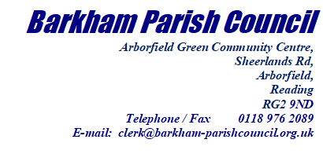

Growth and Delivery Team  
Revised Growth Strategy Consultation  
Wokingham Borough Council  
Shute End, Wokingham, RG40 1BN

Tuesday 18th January 2022

To the Growth and Delivery Team

**RE:** [**Local Plan Update:**](https://www.wokingham.gov.uk/_resources/assets/attachment/full/0/609574.pdf) [**Revised Growth Strategy**](https://www.wokingham.gov.uk/_resources/assets/attachment/full/0/609574.pdf)

Barkham Parish Council have agreed a response for the Local Plan Update Consultation. The response as listed below, only includes the sections from the survey, that the Parish Council wished to respond upon. Sections that the council did not wish to respond to have not been included.

The sections included in this response are: Sections 1, 2, 3, 4, 6, 7, 11, 13, 14, 16 and 17.

**1. Are you responding as a:**

**C:** Local Authority

**2. If you are representing an organisation or individual, please tell us more Which organisation and your job title/role**

Barkham Parish Council – Parish Clerk

**3. Please tell us your address**

Barkham Parish Council, Arborfield Green Community Centre, Sheerlands Road, Arborfield, Reading,

**4. Please tell us your postcode**

RG2 9ND

**6.** [**Spatial strategy**](https://www.wokingham.gov.uk/_resources/assets/attachment/full/0/609618.pdf)**(how we plan for development)**

**The following questions ask to what extent do you agree with the proposed changes to the spatial strategy policy?**

**a. Do you want to comment on the**[**proposed changes to the spatial strategy**](https://www.wokingham.gov.uk/_resources/assets/attachment/full/0/609618.pdf)**?**

Yes

**b. To what extent do you agree with the proposed changes to the spatial strategy policy?**

**1=Agree 2=Somewhat agree 3=Neutral 4=Somewhat disagree 5=Disagree**

|  | **1** | **2** | **3** | **4** | **5** |
| --- | --- | --- | --- | --- | --- |
| The primary focus of new growth through the identification of a new Strategic Development Location at Hall Farm / Loddon Valley | **X** |  |  |  |  |
| The identification of additional growth within and adjacent to existing Strategic Development Locations when consistent with their original vision | **X** |  |  |  |  |
| The identification of modest development across the borough, consistent with the character and accessibility of places | **X** |  |  |  |  |
| The extension of the plan period to 2018/19-2037/38, and an associated update to the development needs | **X** |  |  |  |  |

**c. Please set out your comments, including your reasons for agreeing or disagreeing with the proposed changes. If you would like to suggest any changes, please explain the change you would like to see.**

Barkham Parish Council regards the supporting documents that underpin the conclusions outlined in this consultation to be of high quality which engenders confidence in the stated outcome.

**7. Arborfield Strategic Development Location**

**The following questions ask to what extent do you agree with**[**the proposed changes to the Arborfield SDL policy**](https://www.wokingham.gov.uk/_resources/assets/attachment/full/0/609626.pdf)**?**

**a. Do you want to comment on the proposed changes to the Arborfield Strategic Development Location?**

Yes

**b. To what extent do you agree with the proposed changes to the Arborfield SDL policy?**

**1=Agree 2=Somewhat agree 3=Neutral 4=Somewhat disagree 5=Disagree**

|  | **1** | **2** | **3** | **4** | **5** |
| --- | --- | --- | --- | --- | --- |
| Identification of Westward Cottage, Sheerlands Road for 10 dwellings |  |  | **X** |  |  |

**d. Development guidelines for Arborfield SDL**

**Please set out your comments on the development guidelines. If you would like to propose an amendment, please explain the change you would like to see and why.**

Re development of Westward Cottages, Sheerlands Road

No comment

Re development of the Reading FC Training Ground, Hogwood Park, Barkham.

Although not included in the Table in Section 5.12, it is referred to elsewhere in the consultation documents and especially in Appendix J: Development Guidelines.

At the meeting where outline planning permission for PA163547 on 31 Mar 2021 was granted, Barkham Parish Council (BPC) objected to this development for two reasons:

1. There was no pedestrian access to the site from the direction of Biggs Lane in Arborfield Green – this has now been corrected by proposals to provide access via Hazebrouk Meadows and this must be completed.
2. It is proposed to locate the development on the boundary of the Hogwood Industrial Estate, only separated by a footpath. Objections raised that noise and smells could cause nuisance to new residents, especially during warm summer nights when windows would be open, were dismissed by the Officers because a full survey of noise and odours would be completed prior to construction. It was surprising that the Planning Committee accepted this because a survey today does not guarantee that issues will not arise in the future – machinery wears to become a source of noise, leaks occur to allow odours to drift across the dwellings and new processes may be introduced without adequate controls to ensure nuisance will not be caused. This remains a contentious issue and BPC will raise this again when the reserved matters are brought forward. An alternative layout of the site should be considered that increases the buffer zone between the homes and industrial operations and improves screening.

11. Hall Farm / Loddon Valley Strategic Development Location

The following questions ask to what extent do you agree with [the proposed allocation of Hall Farm / Loddon Valley as a new SDL](https://www.wokingham.gov.uk/_resources/assets/attachment/full/0/609626.pdf)?

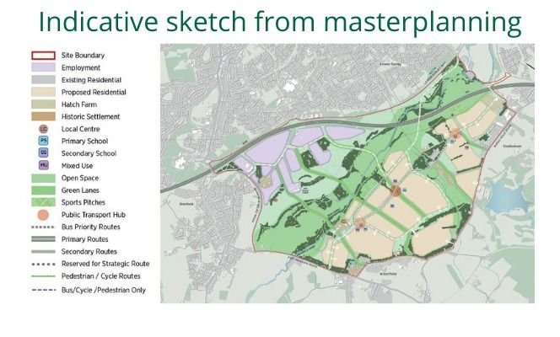

**a. Do you want to comment on the proposed allocation of Hall Farm / Loddon Valley as a Strategic Development Location?**

Yes

**b. To what extent do you agree with the proposed allocation of Hall Farm / Loddon Valley as a new SDL?**

**1=Agree 2=Somewhat agree 3=Neutral 4=Somewhat disagree 5=Disagree**

|  | **1** | **2** | **3** | **4** | **5** |
| --- | --- | --- | --- | --- | --- |
| The identification of a new Strategic Development Location at Hall Farm / Loddon Valley | **X** |  |  |  |  |

**c. Please set out your comments, including your reasons for agreeing or disagreeing with the proposed allocation. If you would like to suggest any changes, please explain the change you would like to see.**

Given the need to build a required number of homes across the Borough, the case for the development of a garden village at Hall Farm/Loddon Valley is compelling. However, it is always regrettable when farmland has to be given over to housing in a way that does not sit well with the joint Arborfield and Barkham Neighbourhood Plan.

Perhaps the greatest benefit of this site is the opportunity to build a sustainable development in close proximity to the M4 and rail links with shortish commuting distances to major centres of employment.

Barkham is a relatively small parish and in 2018 more than 4000 people signed a petition to express concern about the threat of overdevelopment in the immediate area. Barkham Parish Council (BPC) therefore welcomes this proposal which spreads the of loading of new homes development across the Borough.

However, recent and misleading articles in the local press portray a different and wrong scenario which must be put into an accurate context.

These articles implied that under the revised growth strategy Barkham is only receiving 19 new dwellings. Presumably this refers to the 15 gypsy and traveller pitches at Woodland Farm and 4 dwellings on the land north of the Shires.

Under the 2010 Core Plan, 1800 dwellings were allocated to Barkham as part of the Arborfield Garrison SDL with another 1700 just over the parish boundaries.

Since then, the following have been added:

* The 19 dwellings referred to above.
* 140 dwellings on the Reading FC Training Ground as an addition to the SDL
* 270 dwellings at Rooks Nest Farm, which, although attributed to Finchampstead will lie in Barkham.
* Other small privately led developments.

These additional 429 plus homes on top of the original 1800, giving a total of 2229 dwellings, represents a very significant loading in the area. The additional traffic, swelled by the new developments just on the parish boundaries will add further to the congestion of the residential roads that feed into the area.

*Note: There is an inconsistency in format here in Section 11 as, unlike cf Sections 7, 8, 9 and 10, there is no Section d.to allow comment on Development Guidelines. BPC wishes to make two observations under this heading. To allow this to be entered into the questionnaire on line, these two observations are being added here at the end of Section 11c.*

11d. Development guidelines for South Wokingham SDL

To help guide the additional areas, we have prepared development guidelines to be considered in the design, layout and planning of these new areas. The development guidelines for each site are set out in [Appendix J: Development guidelines.](https://www.wokingham.gov.uk/_resources/assets/attachment/full/0/609574.pdf)

1. The interface between Hall Farm/Loddon Valley SDL and the surrounding area needs to be carefully managed to provide gentle and sensitive transition. This could include the planting of trees, non-linear boundaries and graduation of height away from the adjacent areas. Within the development, BPC believes the need to develop interesting areas of greening is well understood.
2. As indicated above, increased traffic across the Borough is of great concern and BPC is pleased to note from the Infrastructure Delivery Plan that considerable provision has been made to address this with regard to the new SDL.   
     
   However, regardless of any measures taken, traffic travelling to Wokingham will inevitably end up on Barkham Road which will only compound the existing congestion on that road. To reduce this impact, such journeys should be discouraged by maximising the sustainability of the Hall Farm/Loddon Valley development and providing frequent and reliable public transport to/from major occupational and recreational centres as well as main line railway stations.

**13. New sites proposed for residential / mixed development**

**The following questions ask to what extent do you agree with the new proposed allocation of land for**[**residential / mixed use development**](https://www.wokingham.gov.uk/_resources/assets/attachment/full/0/609620.pdf)**?**

**a. Do you want to comment on the new sites proposed for residential / mixed use development?**

Yes

**b. To what extent do you agree with the new proposed allocations of land for residential / mixed use development?**

**1=Agree 2=Somewhat agree 3=Neutral 4=Somewhat disagree 5=Disagree**

|  | **1** | **2** | **3** | **4** | **5** |
| --- | --- | --- | --- | --- | --- |
| Rooks Nest Farm and 24 Barkham Ride, Finchampstead |  |  |  | **X** |  |
| 31-33 Barkham Ride, Finchampstead |  |  | **X** |  |  |

**c. Please set out your comments on the new proposed allocations. If you would like to propose an amendment, please explain the change you would like to see and why.**

Re Development at Rooks Nest Farm and 24 Barkham Ride

Although this site is located on the edge of Barkham Parish and is an extension to an existing settlement, it does not sit well with the joint Arborfield and Barkham Neighbourhood Plan (ABNP) which is uncomfortable. That said, the main problem with this proposal is, once again, traffic.

Any attempt to mitigate the increased traffic on Barkham Ride, a narrow country lane with a 6ft 6in width restriction, by widening the road will further impact the rural setting of the area contrary to the ABNP. Further, such a move would not solve any problems but simply move them to Commonfield Lane, Barkham Street and the section of Barkham Ride that passes through Finchampstead.

Re Development at 31-33 Barkham Ride

This location is within the Parish of Finchampstead just on the Barkham – Finchampstead parish boundary. The comments made above re Rooks Nest Farm and 24 Barkham Ride regarding traffic are also particularly relevant here.

**14. Development guidelines for residential / mixed development**

**The following questions ask to what extent do you agree with the development guidelines for the proposed allocations for residential / mixed use development?**

**a. Do you want to comment on the development guidelines for the proposed allocations for residential / mixed use development?**

Yes

**b. To what extent do you agree with the new proposed allocation of land for residential / mixed use development?**

**1=Agree 2=Somewhat agree 3=Neutral 4=Somewhat disagree 5=Disagree**

|  | **1** | **2** | **3** | **4** | **5** |
| --- | --- | --- | --- | --- | --- |
| Land north of The Shires, Barkham | **X** |  |  |  |  |
| Woodlands Farm, Wood Lane, Barkham |  |  |  |  | **X** |
| Rooks Nest Farm and 24 Barkham Ride, Finchampstead |  |  |  | **X** |  |
| 31-33 Barkham Ride, Finchampstead |  |  | **X** |  |  |

**c. Please set out your comments on the development guidelines. If you would like to propose an amendment, please explain the change you would like to see and why.**

Re Land North of the Shires

No comment. Planning application has been granted for a reduced number of houses that is more appropriate to this site.

Re Woodlands Farm, Wood Lane

Barkham Parish Council (BPC) was surprised to see this proposal carried over from the 2020 Consultation because the site has since been sold to Instalcom Ltd – a utility contractor – for use as a logistics depot. That said, an enforcement order to cease operations has been issued by WBC which is now the subject of an appeal.

Should the site, as a result of the appeal, become available again then BPC would like to reaffirm its opposition to the development of this site as presented in its response to the 2020 Consultation.

*It is a brownfield site and in principle BPC applauds the reuse of such areas for residential use. However, there are serious issues affecting the location:*

* *Access from Wood Lane is poor (a narrow right of way and limited highway which is not maintained to full highway standards). It is used by horse riders and walkers and has no pavements. It would need improvement to meet the needs of caravan or mobile home access.*
* *Wood Lane leads onto a bend at the bottom of a hill where there are poor sightlines onto School Road which is heavily congested at peak school times. There are also safety issues from car parking spilling down School Road away from The Coombes School. The additional cars, trucks and caravans will only compound this difficult and unregulated situation and are definitely contra to Policy H12c).*
* *The site is located in countryside which forms part of the settlement gap between Arborfield Cross and Barkham. It is close to The Coombes – a Local Wildlife Site – and any such development would also have an impact on the wildlife which increasingly under pressure.*
* *The site is probably contaminated by industrial usage and would need careful assessment before approving any residential accommodation.*
* *The overall size of the site would appear to be greater than the area needed for 15 pitches. This suggests either that there would be pressure for more development, or that there might be further possibly unregulated development of commercial activity.*
* *The assessment of this site in Appendix B of the HELAA mentions ‘On balance, the site is not considered to be well related to existing houses and therefore new housing development would represent an illogical settlement protrusion’.  As this is a feature of the site and not the use, this comment is equally applicable to assessment in Appendix C of the HELAA and would render it equally unsuitable for any dwellings including pitches.*

Re Rooks Nest Farm and 24 Barkham Ride

Please see comments made in Section 13c.

Re 31-33 Barkham Ride

Please see comments made in Section 13c*.*

**16. Local Green Space**

**The following questions ask to what extent do you agree with the new proposed allocation of land as**[**Local Green Space**](https://www.wokingham.gov.uk/_resources/assets/attachment/full/0/609622.pdf)**?**

**a. Do you want to comment on the new proposed allocations of land as**[**Local Green Space**](https://www.wokingham.gov.uk/_resources/assets/attachment/full/0/609622.pdf)**?**

Yes

**b. To what extent do you agree with the new proposed allocation of land as Local Green Space - Arborfield and Barkham**

**1=Agree 2=Somewhat agree 3=Neutral 4=Somewhat disagree 5=Disagree**

|  | **1** | **2** | **3** | **4** | **5** |
| --- | --- | --- | --- | --- | --- |
| Arborfield Park, Swallowfield Road, Arborfield | **X** |  |  |  |  |
| Pound Copse, Greensward Lane, Arborfield | **X** |  |  |  |  |
| The cricket and rugby pitches within the Arborfield Garrison SDL (A), Princess Marina Drive, Arborfield / Barkham | **X** |  |  |  |  |
| The cricket and rugby pitches within the Arborfield Garrison SDL (B), Princess Marina Drive, Arborfield / Barkham | **X** |  |  |  |  |
| Rook’s Nest Wood Country Park, Barkham Ride, Barkham | **X** |  |  |  |  |
| Hazebrouck Meadows (A), Biggs Lane and Commonfield Lane, Barkham | **X** |  |  |  |  |
| Hazebrouck Meadows (B), Biggs Lane and Commonfield Lane, Barkham | **X** |  |  |  |  |
| Elizabeth Park, The Junipers, Barkham | **X** |  |  |  |  |
| The Junipers, Barkham | **X** |  |  |  |  |

**k. Please set out your comments on the new proposed designations of land as Local Green Space. If you would like to propose an amendment, please explain the change you would like to see and why.**

In response to the 2020 Consultation, Barkham Parish Council (BPC) nominated a number of sites that should be designated as a Local Green Space and all but one has been accepted as indicated in Section 16b above. The exception is The Coombes Woodland area and BPC is concerned that this important and much appreciated recreational area has not been included in the list shown in Section 16b. The Coombes straddles the parishes of Arborfield and Barkham and is of equal importance to both parishes.  
  
It would appear from the entry in the Topic Paper, Local Green Space, November 2021 under reference number LGS044 that this is because a large area of the land described as The Coombes is not readily accessible to the public for any recreational use. The summary conclusion reads as follows:

***No. The nominated area is considered an extensive tract of land which offers some recreational value. The site provides some historical and ecological value, but areas such as Bearwood Estate are not readily accessible to the public for any recreational use. As a result, the site does not warrant further consideration as a Local Green Space.***

The area previously considered can be divided in to two distinct sectors:

Sector 1: This accounts for some 80% (simple estimation) of the 185 hectares area previously considered and includes the Bearwood Estate/Golf Club where there is no general public access for recreational purposes.

Sector 2: The remainder of the above area stretching south of Coombes Lane is the area residents regard as The Coombes for recreational purposes where there is good access via an extensive network of Public Rights of Way (PROWs)1.

BPC contends that Sector 2 DOES satisfy the tests outlined in Section 7.3 of the current consultation document which states that Local Green Space (LGS) designation can only be used where the green space is:

1. In reasonably close proximity to the community it serves.
2. Demonstrably special to the local community and holds particular local significance, recreational values (including as a playing field), tranquillity or richness of its wildlife etc.
3. Local in character and is not an extensive tract of land.

Addressing each of these points in turn:

1. The Topic Paper correctly acknowledges that this area is in close proximity to the settlement of Barkham Hill however the catchment area is greater than this. There are eight well defined access points on the perimeter of the area readily accessible from the surrounding highways. These enable residents from other parts of Barkham such as Langley Common Road, School Road and Barkham Street to also access the heart of The Coombes as well as from those from Arborfield and Sindlesham.
2. This part of The Coombes contributes significantly to Barkham’s identity serving as a common recreational asset within a rural parish where there is no traditional village centre.  
     
   The area is frequently used by walkers, cyclists and horse riders who take advantage of the PROWs – collectively some 3.5km in length – and other more informal pathways. Consequently, although the land is in private ownership, there is a high level of public accessibility. These trails also form a major part of the longer 4.3km Coombes Circular Walk promoted publicly by BPC and WBC alike.  
     
   The area is designated as a Local Geological Site (LGS), a Local Wild Life Site (LWS) and a Habitat of Principal Importance as defined in Section 41 of the Natural Environmental and Rural Communities (NERC) Act 2006. Most of this revised area was added to Natural England’s Ancient Woodland Inventory in 2020.

The distinctiveness of the wooded ‘coombe’ valleys is recognised in the 2020 Landscape Character Assessment. It describes the area as being particularly tranquil with an experience of dark skies despite the close proximity to Wokingham Town. The Topic Paper adds that this conclusion is further supported by CPRE’s Tranquillity Composite Weighted Score (April, 2007) where this area scores highly. This quality was particularly relevant during the Covid 19 pandemic.

The diversity of the wildlife is demonstrated by a consolidated list of species compiled in 2020 identified by surveys conducted in the Coombes by bodies such as BBOWT, RSPB and the Nature Conservancy Council which was registered with the Thames Valley Environmental Records Centre (TVERC). It was based on 1049 observations spanning 433 separate species including 253 plants, 73 birds, 15 mammals, four other animals, 41 fungi, 10 lichens and 37 insects.

1. This significantly reduced area of The Coombes comprises priority lowland mixed deciduous woodlands and topography that contributes to its unique local character. It creates a very distinctive sense of space and is valued highly by local residents, many of whom consider it to be synonymous with Barkham itself.

The area now being proposed for designation as a LGS, estimated to be around 43 hectares, is shown in the map below and broadly follows the southern section of the original area considered as LGS044. It includes the recreation field of some 4 hectares regularly used by pony clubs and BPC feels this is appropriate as this could be granted LGS status in its own right. Some additional areas of ancient woodlands not picked up in LGS044 have been added.

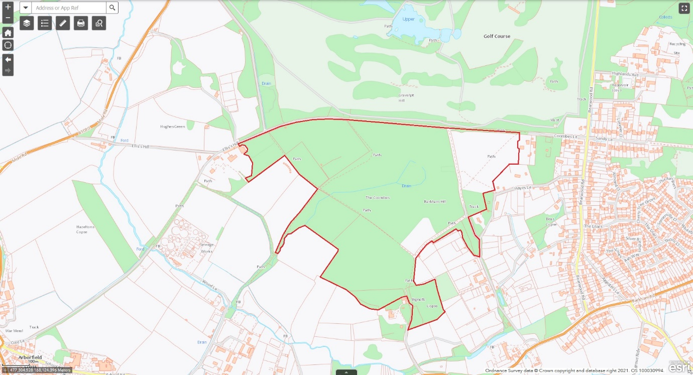

This revised area not only reflects the recreational and public access relevance of the area but the importance to the local community of the historic attributes as reflected by its Ancient Woodland status, the diverse wildlife habitat it provides and its tranquillity as defined in Section 102b of the NPPF.

Consequently, Barkham Parish Council requests the suitability of this area be reassessed for inclusion in the list of Local Green Spaces.

Note 1: The extensive network of PROW includes BA2, BA3, BA4, BA5, BA6, AN9, AN11 and AN12 or sections thereof.

**17. Other matters**

**The focus of this consultation are the questions set out within the consultation document and listed above. Please set out any additional comments you wish to make. In all cases, please set out the reasoning for your comment and, if relevant, the change you would like to see.**

*Protecting the Local Plan and Five-Year Land Supply:*

Part of WBC’s build-up to publishing the current consultation was to stress the **importance of having a current development plan** to deter speculative applications in the future and to provide a basis for providing the required infrastructure in a timely and cost-effective fashion.

The value of such a plan will only be fully realised if it is allowed to be executed as presented here and is not distorted by developers winning opportunistic projects granted by building inspectors on appeal. This means the Five-Year Land Supply (5YLS) has to be protected which in turn means WBC must take a greater role in managing the 5YLS and not leave it to ‘chance’ that the rate of build preferred by developers to maximise profits happens to be compatible with maintaining the 5YLS.

The proposal that the smaller sites are used to balance the build rate, especially where the build rate is back-ended because of the time it takes to provide the required infrastructure for the larger sites, is a useful concept but much more can be done to achieve the required build to maintain the 5YLS. This would require a much more pro-active approach by WBC with respect to:

1. Specifying in decision notices that build-out must be completed by a certain date and not simply begun within three years. The current practice is open to abuse as it allows the foundations for the first house to be dug within three years without any control over when the whole development will be completed.
2. Rescinding planning approvals if delays in commencing construction are evident.
3. Setting steep financial penalties if developers do not deliver the required number of houses on time via liquidated damages.
4. WBC contracting smaller builders directly to build homes at an agreed cost rather than relying on developers developing sites to maximise profits.

The above measures are not difficult but require a determination by WBC to protect the 5YLS and thereby, possibly, maintain some control on the rising price of housing.

*Ensuring Energy Efficiency vis-à-vis The Climate Emergency:*

Although the Draft Local Plan Consultation 2020 makes several references to this in broad terms (eg Policies DH7 to DH10 and HC5), there does not appear to be a simple checklist of specific measures that should be considered as best practice when considering new builds and significant refurbishments. Such a list could be used to challenge developers, builders and owners re the detailed optimisation of the use of energy and include: solar panels, heat pumps, insulation, triple glazing, EV charging points and hydrogen if and when that becomes a reality.

Yours Sincerely

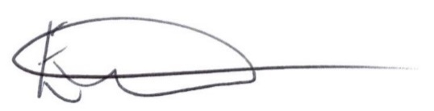

Ellen Tims

Parish Clerk

Barkham Parish Council