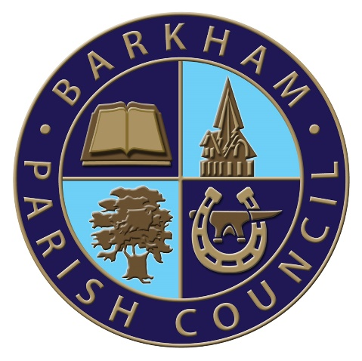
Barkham Parish Council
Arborfield Green Community Centre
Sheerlands Road
Arborfield
RG2 9ND
Tel: 0118 976 2089
Email: clerk@barkham-parishcouncil.org.uk
Clerk: Mrs Ellen Tims

Meeting of the Finance Committee Notice
To be held on Tuesday 28th June 2022
At the Parish Office,
Commencing at 10am

PLEASE NOTE: YOU ARE ASKED NOT TO ATTEND THIS MEETING IF YOU HAVE ANY COVID SYMPTOMS OR HAVE TESTED POSITIVE FOR COVID-19.
The Business to be transacted is as shown under
- Election of Chairman and Vice Chairman
- To receive and consider public questions and comment.
- Apologies for absence with reason given
- Declaration of Members’ interests and requests for dispensation
- To approve the minutes from the last Finance Committee Meeting as being a true record of the meeting
- To receive the latest bank reconciliations and any unplanned expenditure from the RFO
- Reports on matters outstanding and actions arising from the minutes
- To discuss Grant Applications to be put to full council for consideration in May
- AOB
- To set the date of the next meeting
E. Tims
Clerk to the Council

