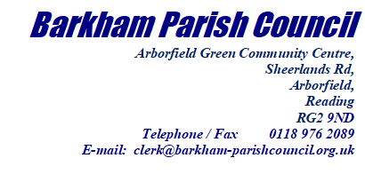
Cllr Clive Jones,
Leader of the Council and Executive Member for Business & Economic Development
Wokingham Borough Council
Shute End
Wokingham
Berkshire
RG40 1BN

30th June 2022

Dear Cllr Jones

Barkham Parish Council (BPC) congratulates you on being elected as Leader of Wokingham Borough Council (WBC) and wishes you every success as you tackle the significant challenges before us all.

We very much support your goal to seek a reduction in the ‘unsustainable’ housing targets and would be very happy to send letters of support wherever appropriate. BPC successfully led a 4000 name petition in 2018 on this very topic and from the many discussions we had with residents whilst collecting the signatures, it is evident you will be well supported.
However, we are uneasy about potential delays, the failure to demonstrate a robust 5 Year Land Supply (5YLS) and the impact on the Local Plan Update (LPU) as outlined below.
- The LPU is long overdue. The current process began in Autumn 2016 - since then we have had a full public consultation for a draft plan during the period Feb to Mar 2020 and, because of the situation at Grazeley, another during the period Nov 2021 to Jan 2022.
We were expecting the results of this latter consultation to be incorporated into the draft plan by Autumn 2022. Are you still working to this schedule?
Any further delay waiting for a reduction in housing numbers or reassessing the assumptions of the previous administration, such as Hall Farm - which, no doubt, the University will build on anyway - will weaken the 5YLS which is already on the cusp. This could result in developments not included in any LPU being approved by planning inspectors on appeal citing Section 11 of the NPPF – ‘presumption in favour of sustainable development’. How will you safeguard against this?
- Regardless of how many new dwellings are included in the final LPU, manipulation of the 5YLS metric gives Developers total control at the expense of the LPU, WBC and residents. To have this measure changed so it reflects land availability – which the name implies – and not a measure of the numbers of houses the Developers decide they want to build would be a start. Better still, remove it altogether. This was on the agenda for the previous administration – is it on yours?

- During the recent elections some of your colleagues in the new administration made commitments to remove some sites from the LPU. If honoured, they will have to be replaced by less sustainable, inappropriate locations with poor access which will lead to a sub-optimal local plan. Is this desirable?

- WBC spends a fortune on preparing the LPU to ensure development is appropriately balanced across the Borough and required infrastructure is delivered in a timely and cost-effective fashion. More is spent on defending appeals. Yet WBC make no attempt to protect the Local Plan from the outset by insisting, contractually, dwellings are built by an agreed date. The condition that construction should begin within a certain time is another area of potential abuse - ‘begin’ could just mean ‘digging a drain’ and gives no assurance of completion. WBC could exert more control if they contracted smaller builders to build homes rather than relying on Developers to develop sites to maximise financial return. Will you be looking at this approach?

These issues are relevant across the entire Borough but Barkham is particularly vulnerable as a relatively small, ’road-locked’ parish. With a failed 5YLS, Developers could bring forward many locations additional to the LPU which would increase housing numbers and add to the overdevelopment of the area and increasing road congestion.
The 2011 census reports there were 1226 households in Barkham. On completion of the Garrison SDL, the proposed developments on the old Reading FC Training Ground and at Rooks Nest Farm, this will approach 3440 – an almost threefold increase in just 25 years. The proposed Solar Farm is another factor. Enough really is enough.

We would welcome the opportunity to discuss with you further the 5YLS metric and your intentions for the direction of the LPU. Why not join one of our regular council meetings?

Meanwhile, we look forward to receiving your comments.

Kind Regards
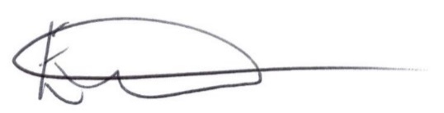
Ellen Tims
Clerk to Barkham Parish Council
For and on Behalf of Barkham Parish Council

Cc Rt Hon Sir John Redwood MP
Cllr Lindsay Ferris
Cllr John Kaiser

