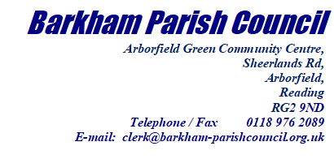The Rt Hon Greg Clark MP,

Secretary of State for Levelling Up, Housing and Communities

2 Marsham Street  
London  
SW1P 4DF

26th July 2022

Dear Minister

Your predecessor, Michael Gove, had agreed to visit Wokingham to discuss housing numbers with the recently elected leadership of Wokingham Borough Council (WBC) and we understand that a similar invitation has been sent to you. Barkham Parish Council (BPC) welcomes this initiative and has already written to Cllr Jones – leader of WBC - on this subject and other related matters.

Regardless of how many houses are included in any Local Plan (LP), planning inspectors can approve additional developments not included in the plan on appeal if the 5 Year Land Supply (5YLS) metric is not satisfied by virtue of Section 11 of the NPPF – ‘the presumption in favour of sustainable development’  
  
The 5YLS is controlled entirely by developers at the expense of local planning authorities, residents and voters. To have this measure changed so it reflects land availability – as the name implies – rather than a measure of the number of dwellings that developers decide they want to build would be a good start. Better still, remove it all together.

Councils like Wokingham spend a fortune on preparing LPs to ensure development is appropriately balanced across the Borough and the required infrastructure is delivered in a timely and cost-effective fashion.

Perversely no attempt is made to protect the Local Plan from the outset by insisting, contractually, that developers actually build dwellings by an agreed date. The condition that construction should begin within a certain time is another area of potential abuse - ‘begin’ could just mean ‘digging a drain’ and gives no assurance of completion. Councils could exert greater control if they contracted more smaller builders to build homes rather than relying on developers to progress sites to maximise financial return***.***

Barkham like many places in the south of England has seen considerable growth already and is vulnerable to opportunistic development as outlined above. The methodology for monitoring and controlling build-out rate is not logical and is detrimental to sound and sensible planning. Hopefully you will be motivated to change this.

Footnote: Barkham is a relatively small semi-rural parish within Wokingham Borough Council. The 2011 census reports there were 1226 households in Barkham and this stands at around 1650 today – an increase of 34%. On completion of the housing already planned this will approach 3440 by 2037 – almost a threefold increase in just 25 years. This is in Barkham alone and there are similar housing projects just over the parish boundaries. In addition, 130 acres have been earmarked for a solar farm project within the parish. Barkham is doing its part and enough really is enough.

Kind Regards

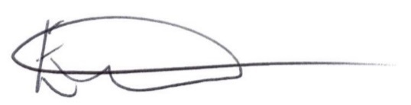

Ellen Tims

Clerk to Barkham Parish Council

For and on Behalf of Barkham Parish Council

Copies to:

Cllr. John Kaiser (Barkham Ward Member)

Cllr. Clive Jones (Leader of Wokingham Borough Council)

Cllr. Lindsay Ferris (Executive Member for Planning)

The Rt Hon Sir John Redwood MP