


Meeting of the Coombes Woodland Committee
To be held on 16th November 2023
at the Parish Office, Arborfield Green Community Centre
Commencing at 10.00am

A G E N D A

- To Elect a Chairman of the Committee Local Government Act 1972 S15(2)

- To receive and accept any apologies for absence Local Government Act 1972 Sch12
Mr Steel – Prior engagements

- To receive any declarations of interest on items on the agenda (Disclosable Pecuniary Interests) Regulations 2012 (SI 2012/1464)
- To Co-opt resident members onto the Committee Local Government Act 1972 S16
The Committee is to agree to co-opting Mr Steel, a resident of Barkham onto the Woodlands Committee.

- Questions from members of the public in respect of the business on this agenda (allotted time 15 minutes) Public Bodies (admissions to meetings) Act 1960 s 1 extended by the LG Act 1972 s 100
Adjournment of the Meeting will be called if any members of the public wish to address the Committee on any matters or concerns relating to The Coombes Woodlands. If you would like to ask a specific question to be answered at the meeting, please submit the question at least 24 hours in advance.
- To note that Insurance to cover the woodlands has been agreed by both Parish Councils.
- For Councillors to:
  - Review and Approve the Tree Survey which has been carried out.
  - Agree a management plan for the works identified from the Survey.
  - Decide whether the tree listed as urgent needs to be removed or reduced / cable braced. The Arboriculturist has said about keeping it as it is an important ancient woodland indicator.
  - Agree temporary measures to make the area around the tree safe until works can be carried out.
  - Develop a management plan for ongoing works to the woodlands (clearing rhododendrons etc)

- Finance
  - To agree a budget to take up to the end of the financial year.
  - Agree to a quote for the urgent tree work required being sought, and to agree to make the decision under delegated authority once received, as it is an urgent item to be remedied.
  - Agree to quotes being obtained for the works identified in the survey to be undertaken, and agree to use the tendering process, if any works go over £25,000.
  - To draft a required budget for the next financial year, to be put to the Councils for approval
  - To consider a contingency Reserve (Ear Marked Reserve) for emergencies that may arise, to be included in the budget for the next financial year, to be put to the Councils for approval.

- AOB

- To set the date of the next meeting

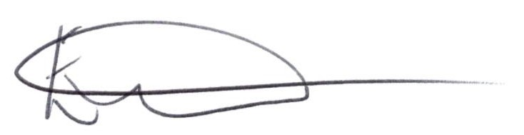

E. Tims, Clerk to the Council

