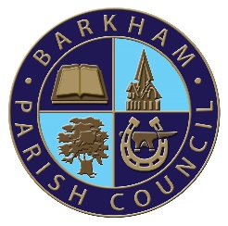

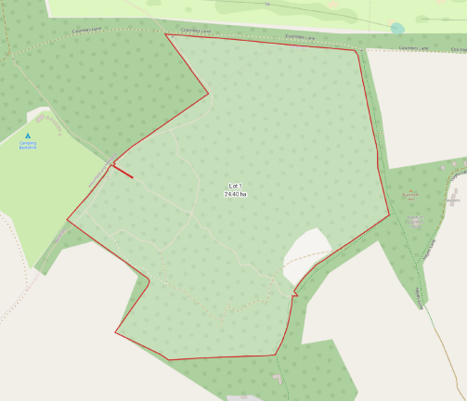
Barkham and Arborfield Parish Councils Unite to Preserve the Coombes Woodland for Community Enjoyment and Education
In a landmark collaborative effort, Barkham Parish Council and Arborfield and Newland Parish Council proudly announce the joint acquisition of 60 acres of The Coombes ancient woodland that sits along the boundary between the two parishes. This initiative will ensure that The Coombes remains open to the public to enjoy in perpetuity and will enable the parishes to take further steps to improve bio-diversity in the area.
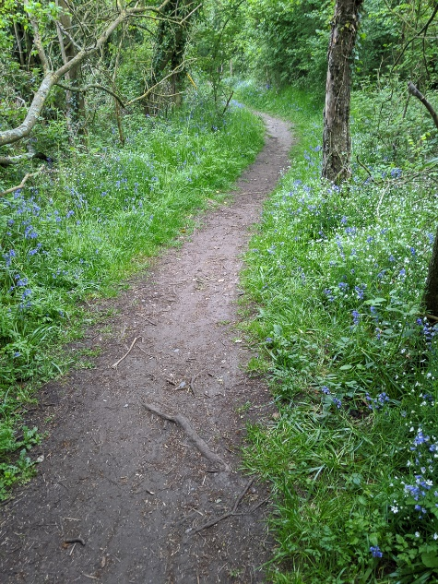
The Coombes woodland is a rare area of ancient woodland in Wokingham Borough and has been enjoyed by local residents for many years. When the property was put on the market the Parish Councils decided they had to act to ensure that the woodland remained accessible to the public for the rest of time. Using Community Infrastructure Levy (CIL) money received from developers building homes across the parishes enabled the councils to purchase the woodland without financial recourse to the local residents.
The plot of The Coombes owned by the parishes
The newly acquired woodland is a vital hub for biodiversity in the area. Recognizing the importance of woodland habitats in supporting diverse ecosystems, the Councils are committed to preserving this natural treasure for the enjoyment of current and future generations of residents and to enhancing the area by working with ecology and woodland conservation organisations to ensure the health of the woodland for years to come.
The Councils also intend to use the woodland for educational purposes and will be seeking opportunities with local schools to enable them to use this important resource as part of their curriculum delivery.
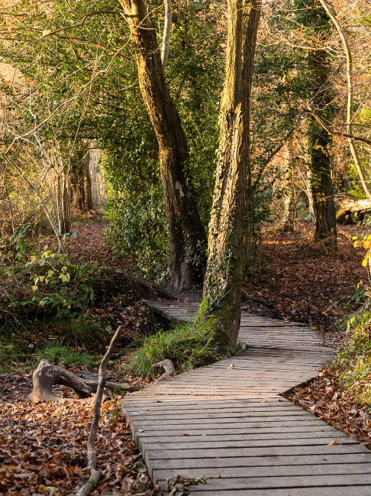
To actively involve the community in the preservation and enhancement of the woodland, the councils are excited to announce plans for the establishment of a volunteer group. Residents will have the opportunity to contribute to the maintenance, improvement, and protection of the woodland through hands-on involvement.
Bluebells in the Spring
Photo credit: Alan Edwards, BVRA
Pam Stubbs, Chair of Barkham Parish Council said: “This day has been a long time coming and by ensuring that The Coombes Woodland is protected and maintained from this moment, we can ensure that future generations will be able to nurture this Ancient Woodland and allow it to thrive for many more centuries.”
Andrew Clint, Chair of Arborfield Parish Council said: “this is a momentous day for the two councils, ensuring The Coombes Woodland will always be accessible to the local residents and will contribute to our goal of making Arborfield an even better place to live. I look forward to seeing how the Coombes Woodland Committee will work to enhance the bio-diversity of the woodland so that we can make a meaningful contribution to leaving our natural world in a better place for future generations”
A Walk in The Woods.
Photo credit: Alan Edwards, BVRA

For further information, please contact:
Ellen Tims Annabel Wood
Clerk to Barkham Parish Council Clerk to Arborfield & Newland Parish Council
0118 976 2089 0118 976 1489
Clerk@barkham-parishcouncil.org.uk parishclerk@arborfield.org.uk

