21.11.2023

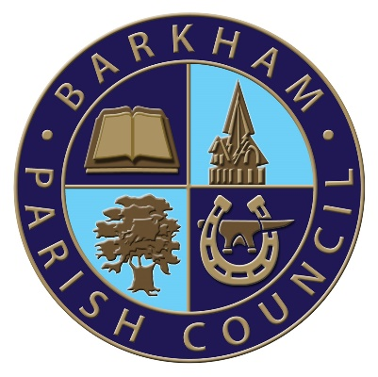

Independent Remuneration Panel

Barkham Parish Council has received the report of the Independent Remuneration Panel appointed to review the allowances paid to councillors of Wokingham Borough’s Parish and Town Councils for 2023/24

This report has provided recommendations from the parish remuneration panel in relation to allowances. These recommendations are for an allowance for elected members of up to 5.1% of the Wokingham Borough Council’s Basic Allowance, or £400 per year and an allowance for the Chair of the Council of up to 15.4% of Wokingham Borough Council’s Basic Allowance, or £1,200, in addition to the basic members allowance.

Copies of the report of the Independent Remuneration Panel are available from the Parish Council in electronic format or in printed format at a cost of £1 per copy, by request to the Parish Clerk
clerk@barkham-parishcouncil.org.uk or 0118 976 2089

