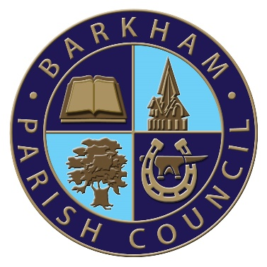

Barkham Parish Council

Parish Assembly
Tuesday 9th April 2024

At

Meeting Room A13, The Office Complex
Arborfield Green Community Centre

Starting at

7.00pm

All residents of Barkham Parish are invited to attend.

7.00pm Welcome – Cllr Pamela Stubbs, Chairman of Barkham Parish Council

7.05pm To agree the minutes from the meeting held on Tuesday 11th April 2023

7.10pm Matters arising

7.15pm Reports from Parish Council and Local Community Bodies

Confirmed:
- Chairmans Report

Invited, not yet confirmed:

- Borough Councillors Report
- Farley Hill Primary School, Barkham
- Barkham Parochial Charities
- St James Church
- BVRA
- Barkham Village Hall

7.30pm Close

Please Note: This is a meeting of the residents and is not a Parish Council meeting.

Pamela Stubbs
Parish Council Chairman

Any queries to the Parish Office on 0118 976 2089 or by email to
clerk@barkham-parishcouncil.org.uk

